|  |
| --- |
| **Name: KEERTHANA DINESH A**  **Roll No: 11**  **Batch: S2MCA-B**  **Date: 06-04-22** |

**NETWORKING & SYSTEM ADMINISTRATION LAB**

**Experiment No.: 1**

# Aim

Identify the major components of a computer system such as Motherboard,RAM Modules,Daughter Cards,Bus Slots,SMPS,Internal Storage Devices and Interfacing Ports.

**Procedure**

# MOTHERBOARD

The motherboard is the main component in the computer system that is used for connecting all the components of the computer system so that they can perform several tasks and functions in the system. The motherboard is considered as the spine of the system as all components are connected to a single circuit board for performing their functions. The motherboard is a costly device and once it gets damaged the user needs to spend a lot of money to buy a new motherboard for a computer system. The motherboard is a central device where all devices are get connected and maintain the flow in the computer system.

## **Components of Motherboard**

Some of the important components of the motherboard are:

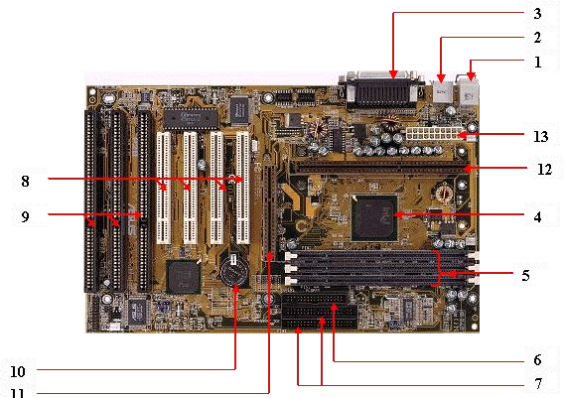

### 1. Keyboard and mouse



There are mainly 2 types of mouse and keyboard connectors. The first connector is known as PS/2 & the second connector is known as USB.

### 2. Universal Serial Bus (USB)



The USB port is used for connecting the computer system. In the computer system, there is various type of devices that are connected with the USB port like keyboard, mouse, camera, scanner, printers, and another device. The main use of a USB port is to connect the peripheral devices and computer motherboards. The peripheral device connected to the computer system can be inserted or remove without system restarts that can be the main advantage of a USB port.

### 3. Parallel port



The old printers that are used in past use the parallel port to connect with the computer system. In the parallel port, multiple wires are used to send or receive multiple bits of the data in a single instance. On the other hand, serial ports use only one wire at a time. In the parallel port, 25 pins female DB type connector is used.

### 4. CPU chip

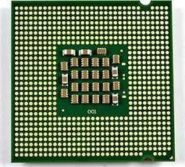

The central processing unit is the processor that controls all the functions of the computer system. The overall flow of task and functions are controlled by the central processing unit. For the computer system, the central processing unit is called the brain of the computer system.

### 5. RAM slots

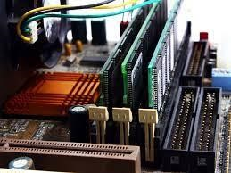

The RAM slots are used for connecting the RAM (memory) in the computer system. In the general computer system, there are mainly two RAM slots but sometimes there can be four-plus slots in the motherboard to increase the memory of the computer system.

### 6. Floppy Controller

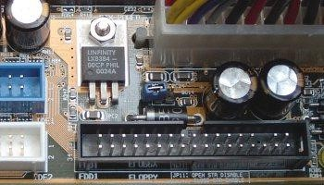

The older motherboard chip contains a 34-pin type ribbon cable for connecting the computer system with a floppy drive. In this ribbon cable, one end is directly connected with the computer system and one end is connected with the motherboard.

### 7. IDE controller

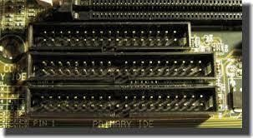

The integrated drive electronics are also known as ATA or Parallel ATA. The IDE is the type of component that issued for hard drive control. In today’s computer system, the IDE controller supports is not supported.

### 8. PCI slot

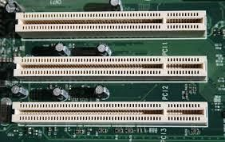

The full form of PCI is a peripheral component interface. The PCI slot is mainly used to insert the expansion cards on the computer. The other PCI devices can also be connected like a sound card, network card, video, card, modems, and other device3s. In today’s computer system support for PCI expansion slots are not there.

### 9. ISA slot

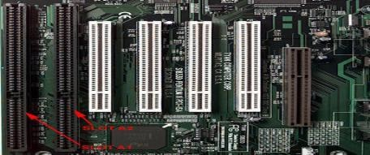

Industry-standard architecture (ISA) is defined as standard architecture for expansion bus. The ISA slot issued for connecting input devices and modems.

### 10. CMOS Battery

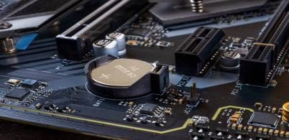

The CMOS battery is used for storing the BIOS settings on the motherboard. The CMOS battery is also capable of storing the time and data in it.

### 11. AGP slot

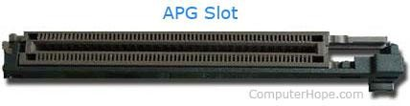

AGP (Accelerated Graphics slot) is a type of computer slot that is used for attaching the video card to the system. This slot is a high-speed slot so that data transfer can be done at high speed.

### 12. CPU slot

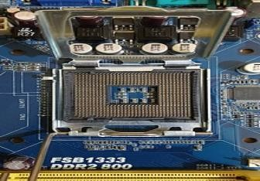

The CPU slot is a type of port that is used to connect the central processing unit to the motherboard of the computer system.

### 13. Power supply slot

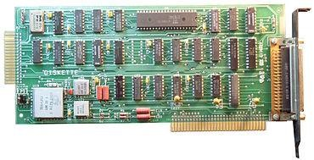

The power supply slot is used for providing the electric supply to the computer system so that it can start and perform its functions. The total power supply given to the system is around 110 ac power. In the power supply type connector, there are a total of 20-pins that are used to maintain the power supply to the computer system.

# RAM MODULES

RAM (Random Access Memory) is the hardware in a computing device where the operating system (OS), application programs and data in current use are kept so they can be quickly reached by the device's processor. RAM is the main memory in a computer. It is much faster to read from and write to than other kinds of storage, such as a hard disk drive (HDD), solid-state drive (SSD) or optical drive.

Random Access Memory is volatile. That means data is retained in RAM as long as the computer is on, but it is lost when the computer is turned off. When the computer is rebooted, the OS and other files are reloaded into RAM, usually from an HDD or SSD.

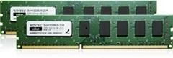

The form factor of any memory module describes its size and pin configuration. Most computer systems have memory sockets that can accept only one form factor. Choices for form factor include:

* SIMM — Single in-line memory module (SIMM) offers a data path of 32 bits. Because Pentium® memory modules are designed to handle a much wider data path than that, SIMMs must be used in pairs on Pentium motherboards (they can be used singly on boards based on 486 or slower processors).
* DIMM — Dual in line memory module (DIMM), which are of more recent origin, offer a 64-bit path, which makes them more suitable for use with the Pentium and other more recent processors. One DIMM will handle the work of two SIMMs and thus can be used singly on a Pentium motherboard. DIMMs are more economical in the long run, because they can be added one at a time to a system.

# DAUGHTER CARDS

A daughter card is similar to an expansion board, but it accesses the motherboard components (memory and CPU) directly instead of sending data through the slower expansion bus.A daughter card is also called a daughterboard,piggyback board, riser card,etc.The daughter board is a computer hardware.A daughterboard is connected directly to the motherboard.Today, these boards are not found or used in desktop computers. They were replaced with ISA cards, PCI cards, and onboard options.Like a motherboard, a daughterboard has sockets, pins, plugs and connectors to be attached to other boards. Typically, daughter boards are released as a post-launch update to a motherboard or expansion card. For example, a MIDI daughterboard is used to add on the functionality of the sound card.

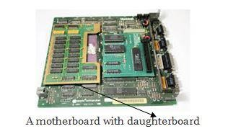

# BUS SLOTS

A bus slot is also known as expansion port, an expansion slot is a connection or port inside a computer on the motherboard or riser card. It provides an installation point for a hardware expansion card to be connected. For example, if you wanted to install a new video card in the computer, you'd purchase a video expansion card and install that card into the compatible expansion slot.

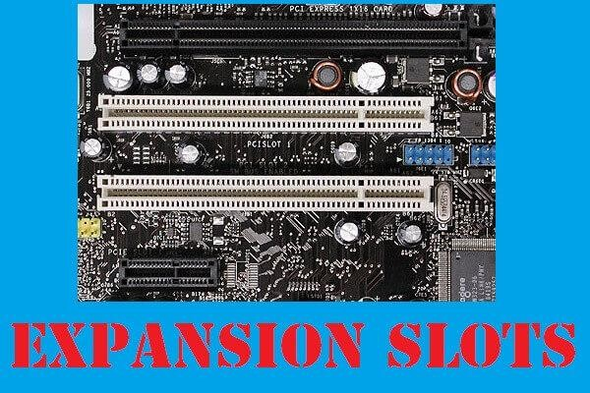

# SMPS

The full form of SMPS is Switched Mode Power Supply also known as Switching Mode Power Supply. SMPS is an electronic power supply system that makes use of a switching regulator to transfer electrical power effectively. It is a PSU (power supply unit) and is usually used in computers to change the voltage to the appropriate range for the computer.

An SMPS adjusts output voltage and current between different electrical configurations by switching the basics of typically lossless storage such as capacitors and inductors.

## Working principles of SMPS

In the SMPS device, the switching regulators are used which switches on and off the load current to maintain and regulate the voltage output. Suitable power generation for a system is the mean voltage between off and on. Unlike the linear power supply, the SMPS carry transistor switches among low dissipation, full-on and full-off phase, and spend much less time in high dissipation cycles, which decreases depleted strength.

## Benefits of SMPS

* The switch-mode power source is small in scale.
* The SMPS is very lightweight.
* SMPS power consumption is typically 60 to 70 per cent, which is ideal for use.
* SMPS is strongly anti-interference.
* The SMPS production range is large.

# INTERNAL STORAGE DEVICES

Most computers have some form of internal storage. The most common type of internal storage is the hard disk.It will also be used to store the applications software that you use and more than likely, the original copies of your data files.

Internal storage allows the data and applications to be loaded very rapidly into memory, ready for use. The data can be accessed much faster than data which is stored on an external storage device. This is because internal storage devices are connected directly to the motherboard and its data bus whereas external devices are connected through a hardware interface such as USB, which means they are considerably slower to access.Internal storage also means that if the computer is moved around, it will still retain its most commonly used data.

The main disadvantage of internal storage is that when the hard disk fails (and it will), all the data and applications may be lost.

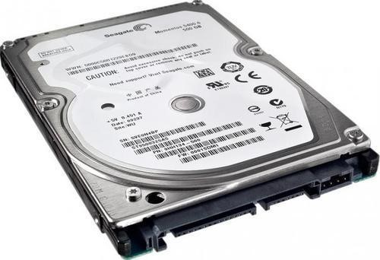

# INTERFACING PORTS

In computer hardware, a port serves as an interface between the computer and other computers or peripheral devices. Some of the common peripherals are mouse, keyboard, monitor or display unit, printer, speaker, flash drive etc.The main function of a computer port is to act as a point of attachment, where the cable from the peripheral can be plugged in and allows data to flow from and to the device.

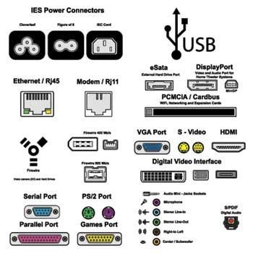

Few important types of ports are:

1.Serial Port

* Used for external modems and older computer mouse
* Two versions: 9 pin, 25 pin model
* Data travels at 115 kilo bits per second.

2. Parallel Port

* Used for scanners and printers
* Also called printer port
* 25 pin model
* IEEE 1284-compliant Centronics port.

3.PS/2 Port

* Used for old computer keyboard and mouse
* Also called mouse port
* Most of the old computers provide two PS/2 port, each for the mouse and keyboard
* IEEE 1284-compliant Centronics port

4.Universal Serial Bus (or USB) Port

* It can connect all kinds of external USB devices such as external hard disk, printer, scanner, mouse, keyboard, etc.
* It was introduced in 1997.
* Most of the computers provide two USB ports as minimum.
* Data travels at 12 megabits per seconds.
* USB compliant devices can get power from a USB port.

5.VGA Port

* Connects monitor to a computer's video card.
* It has 15 holes.
* Similar to the serial port connector. However, serial port connector has pins, VGA port has holes.
* Power Connector
* Three-pronged plug.
* Connects to the computer's power cable that plugs into a power bar or wall socket.

6.Firewire Port

* Transfers large amount of data at very fast speed.
* Connects camcorders and video equipment to the computer.
* Data travels at 400 to 800 megabits per seconds.
* Invented by Apple.
* It has three variants: 4-Pin FireWire 400 connector, 6-Pin FireWire 400 connector, and 9-Pin FireWire 800 connector.

7.Modem Port

* Connects a PC's modem to the telephone network.
* Ethernet Port
* Connects to a network and high speed Internet.
* Connects the network cable to a computer.
* This port resides on an Ethernet Card.
* Data travels at 10 megabits to 1000 megabits per seconds depending upon the network bandwidth.

8.Game Port

* Connect a joystick to a PC
* Now replaced by USB
* Digital Video Interface, DVI port
* Connects Flat panel LCD monitor to the computer's high-end video graphic cards.
* Very popular among video card manufacturers.

9.Sockets

* Sockets connect the microphone and speakers to the sound card of the computer.